Guidelines for Front Runner Public Procurers

Washing Machines  Yuri Vandresen, June 2021 | 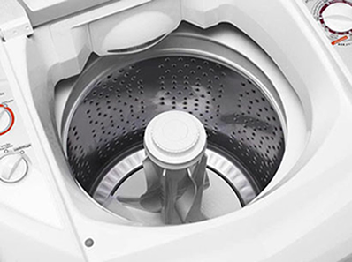

Why follow Topten criteria?

- Topten.eco.br (www.topten.eco.br) is a Brazilian web portal helping buyers, professionals, public procurers and large buyers to find the most energy efficient products available in Brazil. The products are selected and updated continuously, according to their high energy and environmental performances, independently from the manufacturers.
- All washing machines displayed on www.topten.eco.br meet the criteria contained in these guidelines. Procurers can therefore use the website to check the availability and assortment of products currently on the market, which meet the Topten selection criteria.

How much can you save?

Considering washing machines listed on www.topten.eco.br and the following assumptions, it is possible to achieve the savings indicated in the next table.
Assumptions | - Lifetime expectation: 10 years
 | - Yearly use: 220 washing cycles per year
- Electricity cost: R$ 0.59 /kWh
- Water and sewage cost: R$ 15.64 /m³

 | Topten model | Inefficient model
Washing capacity | 12 kg | 12 kg
Energy class | A | B
Electricity consumption | 79 kWh/year | 81.5 kWh/year
Water consumption | 24.2 m³/year | 33 m³/year
Use cost (electricity and water in 10 years) | R$ 4251 | R$ 5642
Savings in 10 years | 0.2% energy/unit - 26% water/unit  R$ 1391 / unit
As the example shows, total savings can reach a 24.7% reduction, and they should be multiplied by the number of units included in the tender.
It is worth mentioning that washing machines vary greatly in regards to their washing capacities, water and energy consumption. The analysis mentioned above is a comparison between models of high and low efficiency with the volume of the most popular models in Brazil. Washing machines with higher volumes are likely to consume more energy, thus a similar percentual reduction in energy consumption equals a greater absolute cost reduction. Models with hot water and/or drying features are also more likely to present a greater potential for cost reduction and energy/water savings.

Procurement criteria

The following criteria can be inserted directly into tendering documents. The Topten selection criteria and the product lists are updated regularly. The newest versions are always available at www.topten.eco.br.

Subject: Highly energy-efficient refrigerators

Technical Specifications
- Energy label
Energy labels for washing machines are also regulated by INMETRO Ordinance nº 20/2006. The regulation defines an energy label scale from A to E, being A the most efficient and E the least efficient category. Washing machine classification on the ENCE scale is based on their efficiency indexes, expressed in energy consumption per cycle per kilogram and it’s split between cold wash, hot wash and centrifugation efficiency, as show on the tables below:
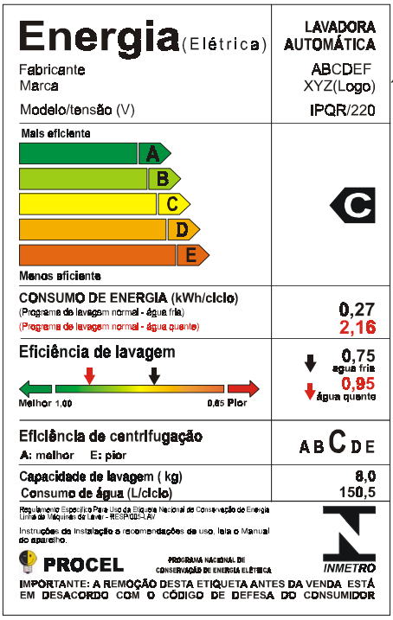 |  |  | INMETRO Ordinance Nº 185/2005
 |  |  | Energy efficiency class | Centrifugation Efficiency (%)
 |  |  | A | 60
 |  |  | B | 68
 |  |  | C | 76
 |  |  | D | 84
 |  |  | E | 94
INMETRO Ordinance Nº 185/2005
Energy Efficiency Class | Cold Wash - Automatic (kWh/cycle/kg) | Cold Wash – Semi-automatic (kWh/cycle/kg) | Hot Wash (kWh/cycle/kg)
A | 0.031 | 0.019 | 0.19
B | 0.035 | 0.022 | 0.23
C | 0.039 | 0.025 | 0.27
D | 0.043 | 0.028 | 0.31
E | 0.047 | 0.031 | 0.35

PROCEL Label
The PROCEL (National Electrical Energy Conservation Program) recognises products that have a higher energy efficiency amongst their competitors. It guarantees lower energy consumption during use and minimum energy efficiency class A.

According to the official PROCEL guideline, washing machines must meet a set of minimum requirements in order to be given the PROCEL label. For automatic and semi-automatic, the requirements are:

Category | Electrical Energy Consumption | Washing efficiency | Water consumption (litres/cycle/kg) | Centrifugation efficiency
Automatic | Minimum ENCE classification “A” | ≥ 0.88 | ≤ 15.1 | Minimum ENCE classification “A”
Semi-automatic | Minimum ENCE classification “A” | ≥ 0.72 | ≤ 27.4 | Does not apply

Advice and support
If you would like further assistance in using the information presented here in your own procurement actions or more information on Topten.eco.br please contact your national Topten team (find the links on Topten.eco.br).

The PROCEL and INMETRO websites also contain valuable legal and practical guidance together with procurement criteria for a range of commonly procured products and services.

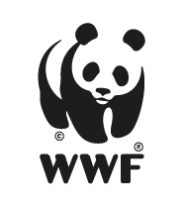 | The elaboration of these procurement guidelines has been supported by funding from WWF Switzerland. The sole responsibility for the content of the Topten procurement guidelines lies with the authors.

Topten ACT has received funding from the European Union's Horizon 2020 research and innovation programme under grant agreement nº649647. The sole responsibility for the content of the Topten Pro procurement guidelines lies with the authors. It does not necessarily reflect the opinion of the European Union. Neither EASME, nor European Commission and project partners are responsible for any use that may be made of the information contained therein.

