Guidelines for Front Runner Public Procurers

Television sets  Yuri Vandresen, June 2021 | 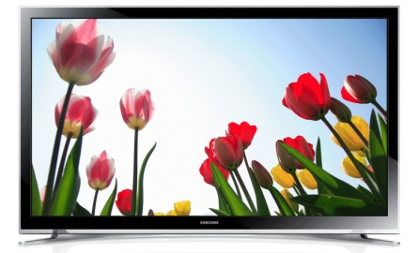

Why follow Topten criteria?

- Topten.eco.br (www.topten.eco.br) is a Brazilian web portal helping buyers, professionals, public procurers and large buyers to find the most energy efficient products available in Brazil. The products are selected and updated continuously, according to their high energy and environmental performances, independently from the manufacturers.
- All television sets displayed on www.topten.eco.br meet the criteria contained in these guidelines. Procurers can therefore use the website to check the availability and assortment of products currently on the market, which meet the Topten selection criteria.

How much can you save?

Considering television sets listed on www.topten.eco.br and the following assumptions, it is possible to achieve the savings indicated in the next table.
Assumptions | - Lifetime expectation: 10 years
 | - Daily use: 4h in on-mode
 | - Electricity cost: 0.59 R$/kWh

 | Topten model | Inefficient model
Screen diagonal | 124cm / 49" | 124 cm / 49"
Energy class | A | A
Resolution | HD | HD
Electricity consumption | 160 kWh/year | 223 kWh/year
Use cost (electricity in 10 years) | R$ 944 | R$ 1316
Savings in 10 years | 28% energy / unit  R$ 372 / unit

As the example shows, total savings can reach 28% reduction, and they should be multiplied by the number of units included in the tender.
Due to longer daily usage, energy consumption and potential savings by TVs are higher in a professional environment than for home TVs. While the annual energy consumption declared on the Energy Label and on Topten.eco.br is calculated based on an assumed usage of 4 hours per day, for professional use one should assume 8 hours per day. This means doubling the absolute amount of energy and money saved, albeit maintaining the percentual economy.

Procurement criteria

The following criteria can be inserted directly into tendering documents. The Topten selection criteria and the product lists are updated regularly. The newest versions are always available at www.topten.eco.br.

Subject: Highly energy-efficient television sets

Technical Specifications
- On-mode power and energy consumption
The on-mode power must be declared according to the ENCE (Energy Conservation National Label). The monthly energy consumption shown in the Energy Label considers a daily usage of 4 hours in on-mode and 20 hours in stand-by mode during 30 days per month.

- Standby and off-mode power consumptions
INMETRO Ordinance nº 563/2014 for televisions states that the maximum power in stand-by mode is 1W. If the maximum power in stand-by mode is higher than 1W the television will be considered non-conformant.

- Energy label
Energy labels for televisions are also regulated by INMETRO Ordinance nº 563/2014. The regulation defines an energy label scale from A to E, being A the most efficient and E the least efficient category. The televisions are categorised based on their Energy Efficiency Indexes (EEI), according to the table below:

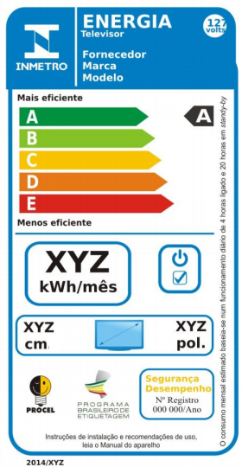 |  |  | INMETRO Ordinance Nº 563/2014
 |  |  | Energy efficiency class | Energy efficiency index
 |  |  | A | EEI < 0.4
 |  |  | B | 0.4 ≤ EEI < 0.5
 |  |  | C | 0.5 ≤ EEI < 0.6
 |  |  | D | 0.6 ≤ EEI < 0.7
 |  |  | E | 0.8 ≤ EEI

PROCEL Label
The PROCEL (National Electrical Energy Conservation Program) recognises products that have a higher energy efficiency amongst their competitors. It guarantees lower energy consumption during use and standby and minimum energy efficiency class A.
For a television model to achieve the PROCEL Label, its Energy Efficiency Index cannot be higher than 0.25. This index is calculated by the following equation:

$$EEI= \frac{PTM}{P_{Ref}}$$

Where PTM is the Medium Total Power and P_{Ref} is the Reference Power, which is calculated in relation to the characteristics of the television and its surface area.

Advice and support
If you would like further assistance in using the information presented here in your own procurement actions or more information on Topten Pro please contact your national Topten team (find the links on Topten.eco.br).

The PROCEL and INMETRO websites also contain valuable legal and practical guidance together with procurement criteria for a range of commonly procured products and services.

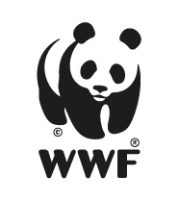 | The elaboration of these procurement guidelines has been supported by funding from WWF Switzerland. The sole responsibility for the content of the Topten procurement guidelines lies with the authors.

Topten ACT has received funding from the European Union's Horizon 2020 research and innovation programme under grant agreement nº649647. The sole responsibility for the content of the Topten Pro procurement guidelines lies with the authors. It does not necessarily reflect the opinion of the European Union. Neither EASME, nor European Commission and project partners are responsible for any use that may be made of the information contained therein.

