Guidelines for Front Runner Public Procurers

Solar Photovoltaic Modules  Yuri Vandresen, June 2021 | 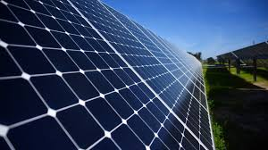

Why follow Topten criteria?

- Topten.eco.br (www.topten.eco.br) is a Brazilian web portal helping buyers, professionals, public procurers and large buyers to find the most energy efficient products available in Brazil. The products are selected and updated continuously, according to their high energy and environmental performances, independently from the manufacturers.
- All photovoltaic modules displayed on www.topten.eco.br meet the criteria contained in these guidelines. Procurers can therefore use the website to check the availability and assortment of products currently on the market, which meet the Topten selection criteria.

How much can you save?

Considering photovoltaic modules listed on www.topten.eco.br and the following assumptions, it is possible to achieve the savings indicated in the next table.
Assumptions | - Lifetime expectation: 20 years
 | - Monthly energy generation: as stated on the energy label (INMETRO Ordinance nº 004/2011)
 | - Electricity cost: 0.59 R$/kWh

 | Topten model | Inefficient model
Nominal power | 327 Wp | 300 Wp
Energy class | A | A
Electricity generation | 491 kWh/year | 450 kWh/year
Total savings (electricity in 20 years) | R$ 5794 | R$ 5310
Savings in 20 years | 8,4% energy / unit  R$ 484 / unit
As the example shows, total savings can reach a 8,4% reduction, and they should be multiplied by the number of units included in the tender.

Procurement criteria

The following criteria can be inserted directly into tendering documents. The Topten selection criteria and the product lists are updated regularly. The newest versions are always available at www.topten.eco.br.

Subject: Highly energy-efficient PV Modules

Technical Specifications
- Energy Efficiency Index
According to INMETRO Ordinance nº 357/2014, photovoltaic module efficiency is defined by the ratio between maximum electrical power supplied by the module on standard test conditions (25ºC, AM 1.5, 1000 W/m², according to IEC 61215) and the product of module area and the solar irradiation of the same conditions. That means that the EEI represents how well the PV module can convert the maximum solar power that hits the module into electrical power.

- Photovoltaic module categories
According to the appendix A of INMETRO Ordinance nº 004/2011, photovoltaic modules are split into two major categories and the testing of each category follows a specific international normative, as shown on the table below:

Category | Nomenclature | Normative
1 | Crystalline Silicon Terrestrial PV Modules | IEC 61215
2 | Thin-film Terrestrial PV Modules | IEC 61646

- Energy label
Energy labels for photovoltaic modules are also regulated by INMETRO Ordinance nº 004/2011. The regulation defines an energy label scale from A to E, being A the most efficient and E the least efficient category. Photovoltaic modules are categorised based on their Energy Efficiency Index (EEI), and are different for crystalline silicon and thin-film modules, according to the tables below:

- Crystalline Silicon (mono-si or poly-si):
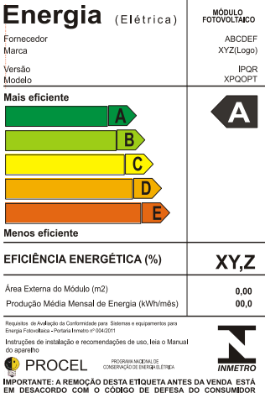 |  |  | INMETRO Ordinance Nº 04/2011
 |  |  | Energy efficiency class | Energy efficiency index
 |  |  | A | EEI > 13,5%
 |  |  | B | 13% < EEI ≤ 13,5%
 |  |  | C | 12% < EEI ≤ 13%
 |  |  | D | 11% ≤ EEI < 12%
 |  |  | E | EEI < 11%
- Thin-film:

 |  |  | INMETRO Ordinance Nº 04/2011
 |  |  | Energy efficiency class | Energy efficiency index
 |  |  | A | EEI > 9,5%
 |  |  | B | 7,5% < EEI ≤ 9,5%
 |  |  | C | 6,5% < EEI ≤ 7,5%
 |  |  | D | 5,0% ≤ EEI < 6,5%
 |  |  | E | EEI < 5%

PROCEL Label
The PROCEL (National Electrical Energy Conservation Program) recognises products that have a higher energy efficiency amongst their competitors. For a photovoltaic module to receive the PROCEL Label, its Energy Efficiency Index must be eligible for the energy efficiency class A.

Advice and support
If you would like further assistance in using the information presented here in your own procurement actions or more information on Topten.eco.br please contact your national Topten team (find the links on Topten.eco.br).

The PROCEL and INMETRO websites also contain valuable legal and practical guidance together with procurement criteria for a range of commonly procured products and services.

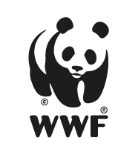 | The elaboration of these procurement guidelines has been supported by funding from WWF Switzerland. The sole responsibility for the content of the Topten procurement guidelines lies with the authors.

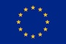 | Topten ACT has received funding from the European Union's Horizon 2020 research and innovation programme under grant agreement nº649647. The sole responsibility for the content of the Topten Pro procurement guidelines lies with the authors. It does not necessarily reflect the opinion of the European Union. Neither EASME, nor European Commission and project partners are responsible for any use that may be made of the information contained therein.

