Guidelines for Front Runner Public Procurers

Microwaves  Yuri Vandresen, June 2021 | 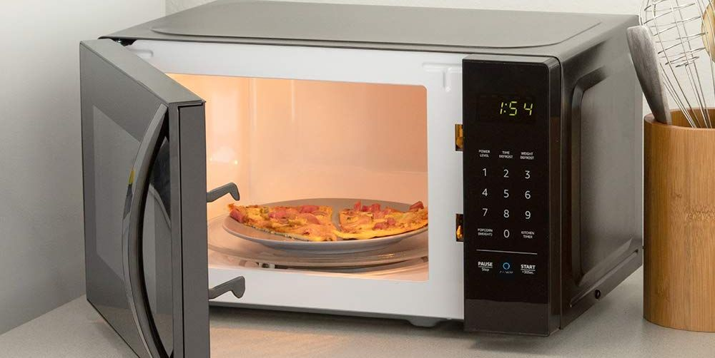

Why follow Topten criteria?

- Topten.eco.br (www.topten.eco.br) is a Brazilian web portal helping buyers, professionals, public procurers and large buyers to find the most energy efficient products available in Brazil. The products are selected and updated continuously, according to their high energy and environmental performances, independently from the manufacturers.
- All microwaves displayed on www.topten.eco.br meet the criteria contained in these guidelines. Procurers can therefore use the website to check the availability and assortment of products currently on the market, which meet the Topten selection criteria.

How much can you save?

Considering microwaves listed on www.topten.eco.br and the following assumptions, it is possible to achieve the savings indicated in the next table.
Assumptions | - Lifetime expectation: 10 years
 | - Daily use: on-mode used 25 minutes per day, stand-by mode constantly
 | - Electricity cost: 0.59 R$/kWh

 | Topten model | Inefficient model
Product volume | 20 litres | 24 litres
Energy class | A | B
Electricity consumption | 112 kWh/year | 151 kWh/year
Use cost (electricity in 10 years) | R$ 660 | R$ 890
Savings in 10 years | 25% energy / unit  R$ 230 / unit

As the example shows, total savings can reach a 25% reduction, and they should be multiplied by the number of units included in the tender.
It’s worth mentioning that microwaves vary greatly in regards to their useful volumes and energy consumption. The analysis mentioned above is a comparison between models of high and low efficiency with the volume of the most popular models in Brazil. Microwaves with higher volumes and heating power are likely to consume more energy, thus a similar percentual reduction in energy consumption equals a greater absolute cost reduction.

Procurement criteria

The following criteria can be inserted directly into tendering documents. The Topten selection criteria and the product lists are updated regularly. The newest versions are always available at www.topten.eco.br.

Subject: Highly energy-efficient microwaves

Technical Specifications
- Energy Efficiency Index
According to INMETRO Ordinance nº 174/2012, microwave efficiency is calculated via an index called EEI – Energy Efficiency Index. This number reflects the overall electrical energy consumption efficiency, and it’s calculated through a formula that takes into account the necessary time to heat up a predefined amount of water and the total energy consumption of the process, amongst other variables (as specified on the ordinance). All models must present a minimum value of 45% to be considered compliant with regulation and be allowed to be commercialised.

- Stand-by mode and on-mode consumption
The stand-by mode energy consumption is measured according to the IEC 62301 and it considers that the microwave is permanently connected to the electricity source (24hr/day). The measurement of stand-by mode energy consumption, albeit mandatory, is solely for informative purposes, not being a criterion for of the rejection of the microwave device on INMETRO. For the on-mode consumption, it’s assumed that the average use of microwaves is 25 minutes a day in a 30-day month and that the product is used at nominal power.

- Energy label
Energy labels for microwaves are also regulated by INMETRO Ordinance nº 174/2012. The regulation defines an energy label scale from A to C, being A the most efficient and C the least efficient category. Refrigerators are categorised based on their Energy Efficiency Indexes (EEI), according to the table below:

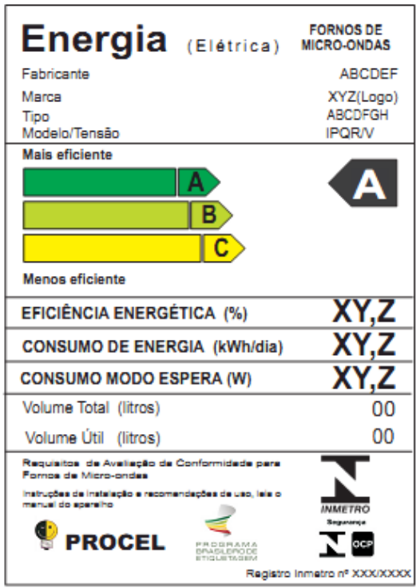 |  |  | INMETRO Ordinance Nº 20/2006
 |  |  | Energy efficiency class | Energy efficiency index
 |  |  | A | EEI ≥ 54%
 |  |  | B | 54% > EEI ≥ 49%
 |  |  | C | 49% > EEI ≥ 45%

PROCEL Label
The PROCEL (National Electrical Energy Conservation Program) recognises products that have a higher energy efficiency amongst their competitors. It guarantees lower energy consumption during use and standby and minimum energy efficiency class A.
For a microwave model to receive the PROCEL Label, its Energy Efficiency Index must be higher than 54% and the stand-by power must be equal or lower than 1.50W.

Advice and support
If you would like further assistance in using the information presented here in your own procurement actions or more information on Topten.eco.br please contact your national Topten team (find the links on Topten.eco.br).
The PROCEL and INMETRO websites also contain valuable legal and practical guidance together with procurement criteria for a range of commonly procured products and services.

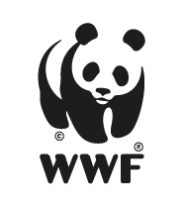 | The elaboration of these procurement guidelines has been supported by funding from WWF Switzerland. The sole responsibility for the content of the Topten procurement guidelines lies with the authors.

Topten ACT has received funding from the European Union's Horizon 2020 research and innovation programme under grant agreement nº649647. The sole responsibility for the content of the Topten Pro procurement guidelines lies with the authors. It does not necessarily reflect the opinion of the European Union. Neither EASME, nor European Commission and project partners are responsible for any use that may be made of the information contained therein.

