Guidelines for Front Runner Public Procurers

Fans  Yuri Vandresen, June 2021 | 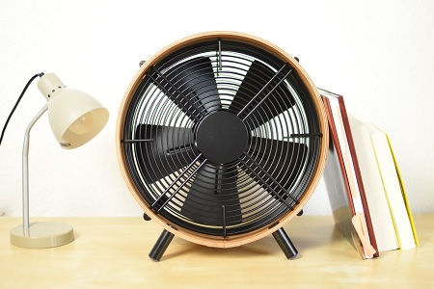

Why follow Topten criteria?

- Topten.eco.br (www.topten.eco.br) is a Brazilian web portal helping buyers, professionals, public procurers and large buyers to find the most energy efficient products available in Brazil. The products are selected and updated continuously, according to their high energy and environmental performances, independently from the manufacturers.
- All fans displayed on www.topten.eco.br meet the criteria contained in these guidelines. Procurers can therefore use the website to check the availability and assortment of products currently on the market, which meet the Topten selection criteria.

How much can you save?

Considering fans listed on www.topten.eco.br and the following assumptions, it is possible to achieve the savings indicated in the next table.
Assumptions | - Lifetime expectation: 10 years
 | - Daily use: 1h in high-speed mode
 | - Electricity cost: 0.59 R$/kWh

 | Topten model | Inefficient model
Blade diameter | 40 cm | 50 cm
Energy class | A | B
Electricity consumption | 26 kWh/year | 35 kWh/year
Use cost (electricity in 10 years) | R$ 153 | R$ 206
Savings in 10 years | 25,7% energy / unit  R$ 53 / unit
As the example shows, total savings can reach 25.7% reduction, and they should be multiplied by the number of units included in the tender.

Procurement criteria

The following criteria can be inserted directly into tendering documents. The Topten selection criteria and the product lists are updated regularly. The newest versions are always available at www.topten.eco.br.

Subject: Highly energy-efficient Fans

Technical Specifications
- Energy Efficiency Index
According to INMETRO Ordinances Nº 113/2008 and Nº 020/2012, the energy efficiency index (EEI) for tabletop fans is calculated for high, medium and low speeds separately and is expressed through the quotient between air flow speed (m³/s) and the electrical power consumed (W). To allow the comparison between devices of different blade diameter, the index shown on Energy Labels is called Normalized Efficiency and consists of the product between the EEI (m³/s/W) and the diameter (m).

- Minimum air flow
The same INMETRO Ordinances state the minimum air flow for low, medium and high speeds that the devices must show on the tests to be able to use the ENCE (National Energy Conservation Label), as shown on the table below:

- Tabletop fans:
Speed | Minimum air flow
High | 0.45 m³/s
Medium | 0.37 m³/s
Low | 0.33 m³/s

- Roof-mounted fans:
Speed | Minimum air flow
High | 1.75 m³/s
Medium | 1.18 m³/s
Low | 0.59 m³/s

- Energy label
Energy labels for roof-mounted and tabletop fans are also regulated by INMETRO Ordinances nº 563/2014 and Nº 020/2012. The regulation defines an energy label scale from A to D or E, being A the most efficient and D or E the least efficient category. The fans are categorised based on their Energy Efficiency Indexes (EEI), according to the table below:
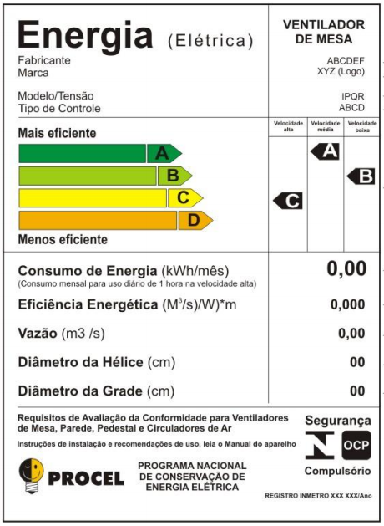
- Tabletop fans:
Class | High Speed | Medium Speed | Low Speed
A | EEI > 0.0040 | EEI > 0.0040 | EEI > 0.0040
B | 0.0040 ≥ EEI > 0.0035 | 0.0040 ≥ EEI > 0.0035 | 0.0040 ≥ EEI > 0.0035
C | 0.0035 ≥ EEI > 0.0030 | 0.0035 ≥ EEI > 0.0030 | 0.0035 ≥ EEI > 0.0030
D | EEI ≤ 0.0030 | EEI ≤ 0.0030 | EEI ≤ 0.0030

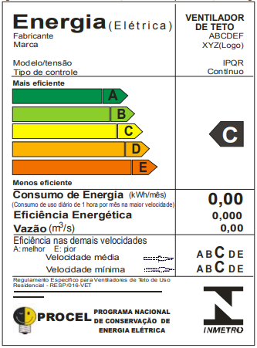
- Roof-mounted fans:
Class | High Speed | Medium Speed | Low Speed
A | EEI > 0.019 | EEI > 0.022 | EEI > 0.020
B | 0.019 ≥ EEI > 0.017 | 0.022 ≥ EEI > 0.020 | 0.020 ≥ EEI > 0.018
C | 0.017 ≥ EEI > 0.015 | 0.020 ≥ EEI > 0.018 | 0.018 ≥ EEI > 0.016
D | 0.015 ≥ EEI > 0.014 | 0.018 ≥ EEI > 0.016 | 0.016 ≥ EEI > 0.013
E | EEI ≤ 0.014 | EEI ≤ 0.016 | EEI ≤ 0.013

PROCEL Label
The PROCEL (National Electrical Energy Conservation Program) recognises products that have a higher energy efficiency amongst their competitors. It guarantees lower energy consumption during use.
For tabletop and roof-mounted fans, the PROCEL Label is given to those products that reach the A classification. For three-speed models, the requirement is that they possess an A classification in all three velocities simultaneously

Advice and support
If you would like further assistance in using the information presented here in your own procurement actions or more information on Topten Pro please contact your national Topten team (find the links on Topten.eco.br).

The PROCEL and INMETRO websites also contain valuable legal and practical guidance together with procurement criteria for a range of commonly procured products and services.

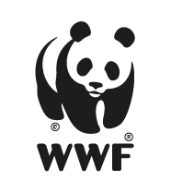 | The elaboration of these procurement guidelines has been supported by funding from WWF Switzerland. The sole responsibility for the content of the Topten procurement guidelines lies with the authors.

Topten ACT has received funding from the European Union's Horizon 2020 research and innovation programme under grant agreement nº649647. The sole responsibility for the content of the Topten Pro procurement guidelines lies with the authors. It does not necessarily reflect the opinion of the European Union. Neither EASME, nor European Commission and project partners are responsible for any use that may be made of the information contained therein.

