Guidelines for Front Runner Public Procurers

Air Conditioners  Yuri Vandresen, June 2021 | 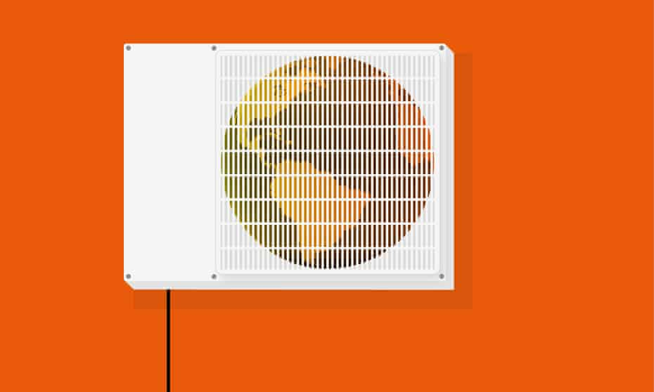

Why follow Topten criteria?

- Topten.eco.br (www.topten.eco.br) is a Brazilian web portal helping buyers, professionals, public procurers and large buyers to find the most energy efficient products available in Brazil. The products are selected and updated continuously, according to their high energy and environmental performances, independently from the manufacturers.
- All air conditioners displayed on www.topten.eco.br meet the criteria contained in these guidelines. Procurers can therefore use the website to check the availability and assortment of products currently on the market, which meet the Topten selection criteria.

How much can you save?

Considering air conditioners listed on www.topten.eco.br and the following assumptions, it is possible to achieve the savings indicated in the next table.
Assumptions | - Lifetime expectation: 10 years
 | - Daily use: 1h per day during the whole year
 | - Electricity cost: 0.59 R$/kWh

 | Topten model | Inefficient model
Cooling capacity | 9,000 BTU/h | 9,000 BTU/h
Energy class | A | A
Electricity consumption | 187 kWh/year | 228 kWh/year
Use cost (electricity in 10 years) | R$ 1103 | R$ 1345
Savings in 10 years | 17,9% energy / unit  R$ 242 / unit

As the example shows, total savings can reach a 17,9% reduction, and they should be multiplied by the number of units included in the tender.
It’s worth mentioning that air conditioners vary greatly in regards to their cooling capacity and energy consumption. The analysis mentioned above is a comparison between models of high and low efficiency with the volume of the most popular models in Brazil. Air conditioners with higher cooling capacities are likely to consume more energy, thus a similar percentual reduction in energy consumption equals a greater absolute cost reduction.

Procurement criteria

The following criteria can be inserted directly into tendering documents. The Topten selection criteria and the product lists are updated regularly. The newest versions are always available at www.topten.eco.br.

Subject: Highly energy-efficient Air Conditioners

Technical Specifications
- Energy Efficiency Index
According to INMETRO Ordinance nº 007/2011, air conditioner efficiency is expressed through an index called SCPI – Seasonal Cooling Performance Index. This number reflects the ratio between the total annual amount of heat that the air conditioner can remove from indoor air and the electrical energy consumed by the equipment during the same period of time. Both variables are expressed in Watts (W).

- Air conditioner categories
According to the same INMETRO Ordinance, air conditioners are split into 4 different categories, which take into account their place of installation as well as the technology used on the model (split or window). The categories are represented on the table below:

Category | Nomenclature
1 | Window
2 | Split Hi-Wall
3 | Split Wall-mounted
4 | Split Cassette

- Energy label
Energy labels for air conditioners are also regulated by INMETRO Ordinance nº 20/2006. The regulation defines an energy label scale from A to D for window ACs and from A to F for split ACs, being A the most efficient and D or E the least efficient class, depending on the category. Air Conditioners are classified based on their SCPI, and the classes are different for window and split models, as shown on the tables below:

Window AC Classification

Class | Seasonal Cooling Performance Index – SCPI (INMETRO Ordinance nº 007/2011)
 | Category 1  ≤ 9.000 Btu/h | Category 2  9.001 to 13.999 Btu/h |  | Category 3  14.000 to 19.999 Btu/h | Category 2  ≥ 20.000 Btu/h
A | ≥ 3.10 |  | ≥ 3.21 | ≥ 2.95 | ≥ 2.89
B | ≥ 3.01 |  | ≥ 3.12 | ≥ 2.87 | ≥ 2.81
C | ≥ 2.93 |  | ≥ 3.03 | ≥ 2.79 | ≥ 2.72
D | ≥ 2.84 |  | ≥ 2.94 | ≥ 2.71 | ≥ 2.65

- Split AC Classification
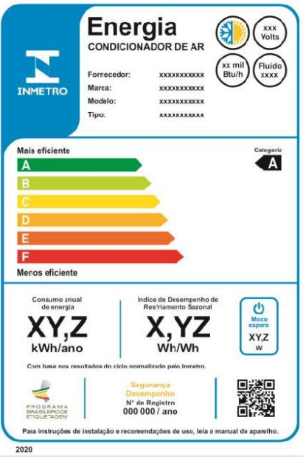 |  |  | INMETRO Ordinance Nº 004/2011
 |  |  | Energy efficiency class | SCPI (Wh/Wh)
 |  |  | A | ≥ 5.50
 |  |  | B | ≥ 5.00
 |  |  | C | ≥ 4.50
 |  |  | D | ≥ 4.00
 |  |  | E | ≥ 3.50
 |  |  | F | ≥ 3.14
PROCEL Label
The PROCEL (National Electrical Energy Conservation Program) recognises products that have a higher energy efficiency amongst their competitors. It guarantees lower energy consumption during use and stand-by modes and minimum energy efficiency class A.
For an air conditioner model to receive the PROCEL Label, the requirements are:
- Be class A according to the SCPI table mentioned above
- Have a stand-by power equal or smaller than 6 W
- Its refrigerant fluid has to have a ODP (Ozone Depletion Potential) of 0 and a GWP (Global Warming Potential) equal or smaller than 2088

Advice and support
If you would like further assistance in using the information presented here in your own procurement actions or more information on Topten.eco.br please contact your national Topten team (find the links on Topten.eco.br).
The PROCEL and INMETRO websites also contain valuable legal and practical guidance together with procurement criteria for a range of commonly procured products and services.

The elaboration of these procurement guidelines has been supported by funding from WWF Switzerland. The sole responsibility for the content of the Topten procurement guidelines lies with the authors.

Topten ACT has received funding from the European Union's Horizon 2020 research and innovation programme under grant agreement nº649647. The sole responsibility for the content of the Topten Pro procurement guidelines lies with the authors. It does not necessarily reflect the opinion of the European Union. Neither EASME, nor European Commission and project partners are responsible for any use that may be made of the information contained therein.

